AI Assignment2:

Task 1:
Use Google Gemini in Colab to write a Python function that reads
a list of numbers and calculates the mean, minimum, and
maximum values
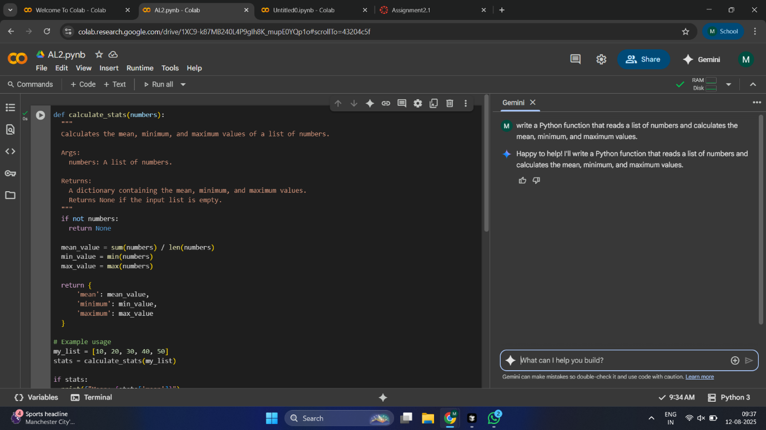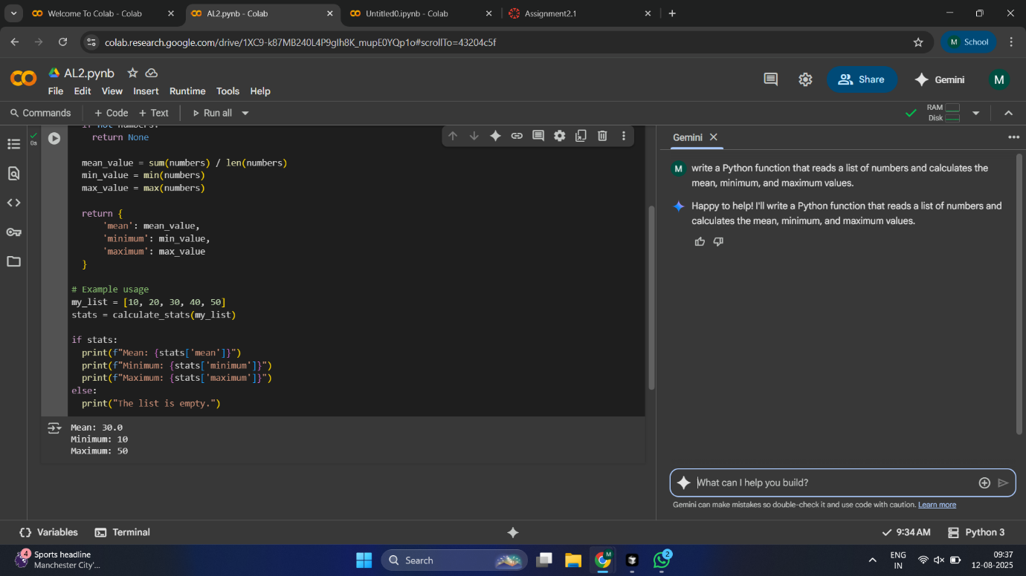

Task 2:
Compare Gemini and Copilot outputs for a Python function that
checks whether a number is an Armstrong number. Document the
steps, prompts, and outputs
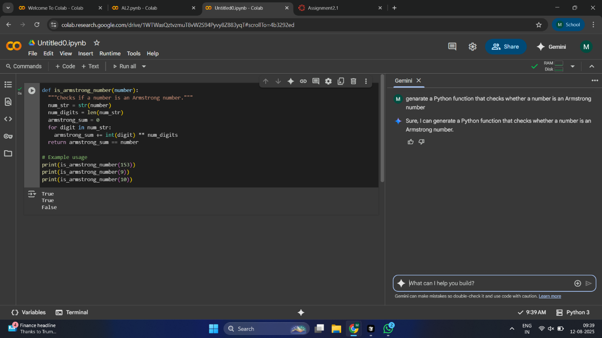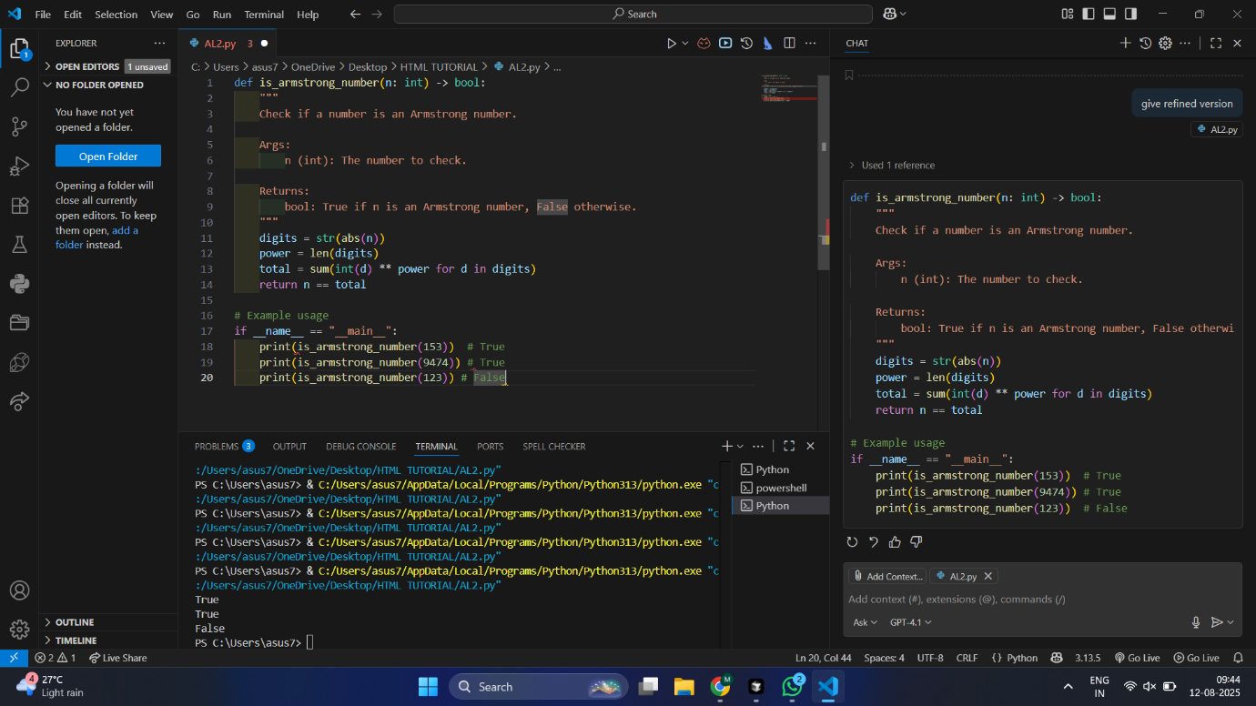

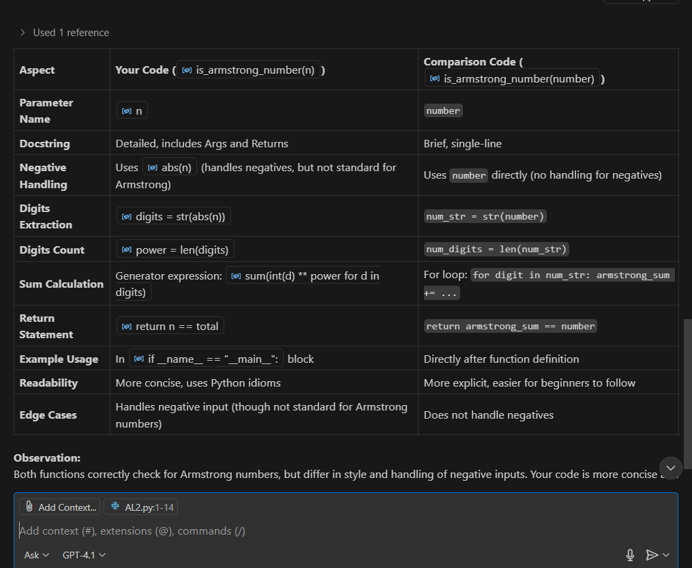

Task 3:
Ask Gemini to explain a Python function (e.g., is_prime(n) or
is_palindrome(s)) line by line.
Choose either a prime-checking or palindrome-checking function
and document the explanation provided by Gemini
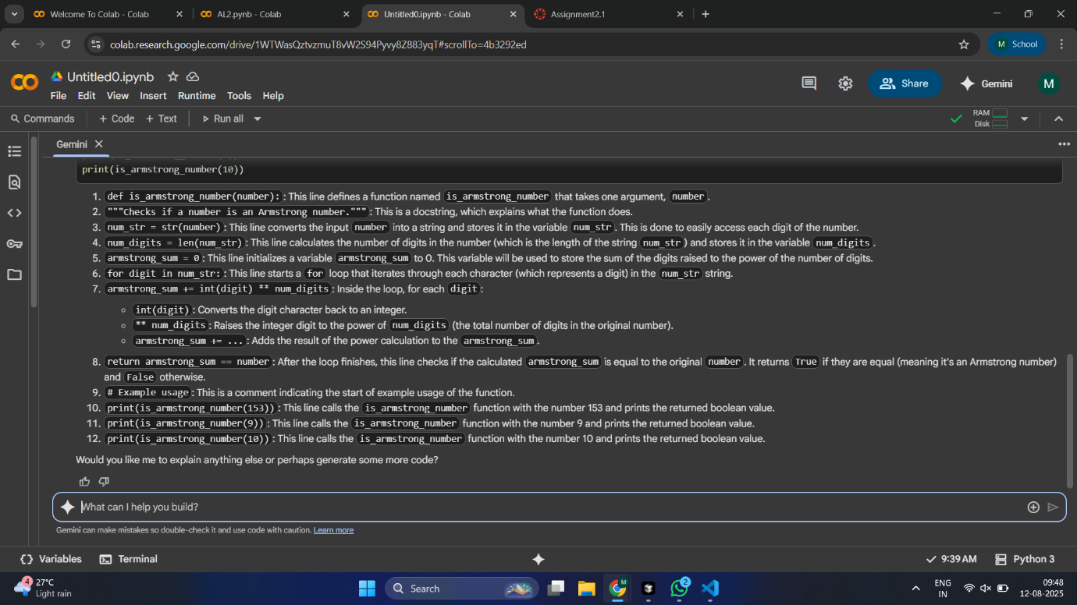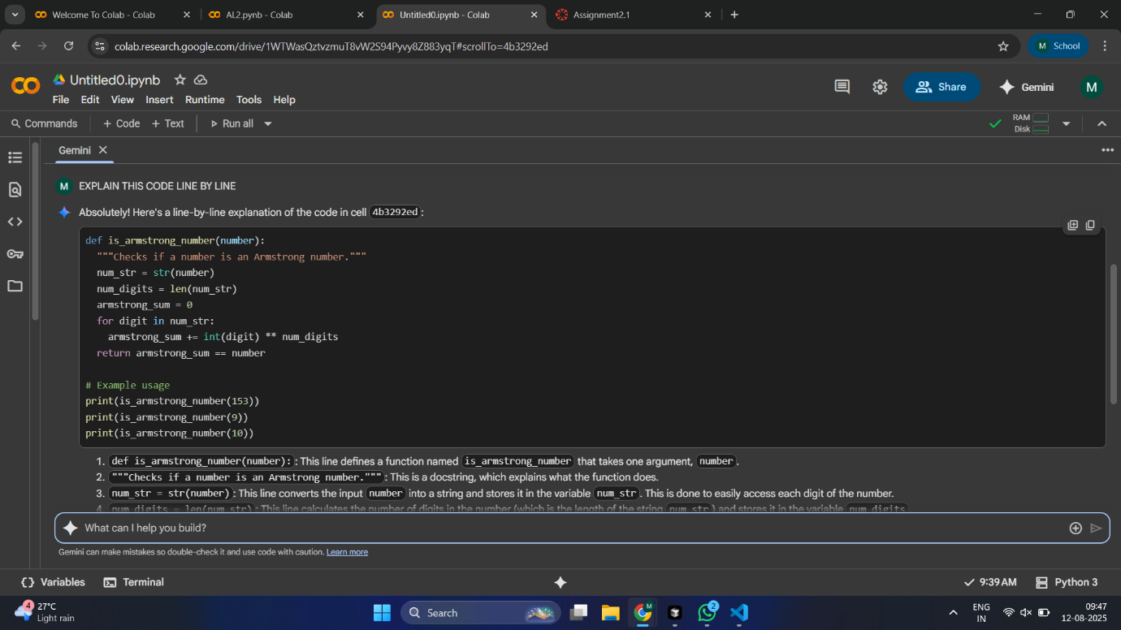

Task 4:
Install and configure Cursor AI. Use it to generate a Python
function (e.g., sum of the first N natural numbers) and test its
output.

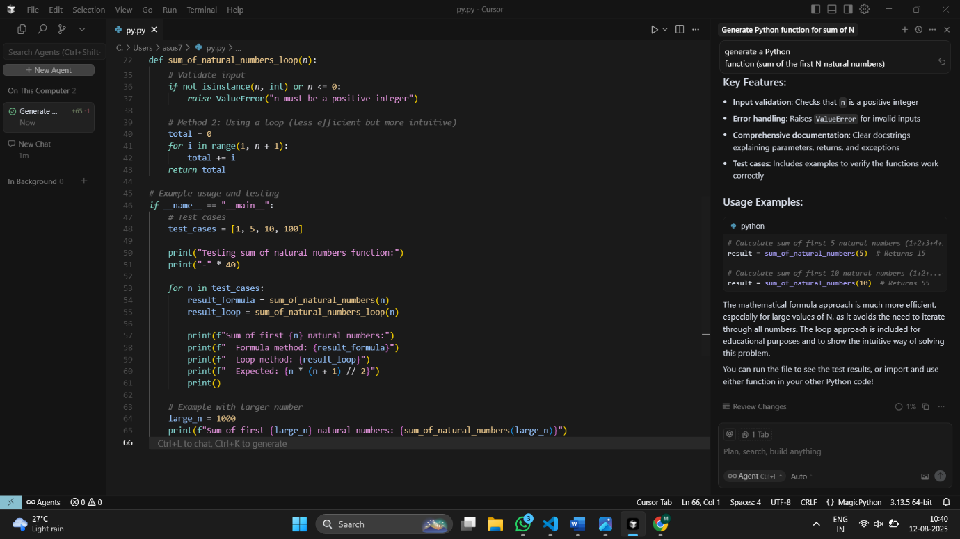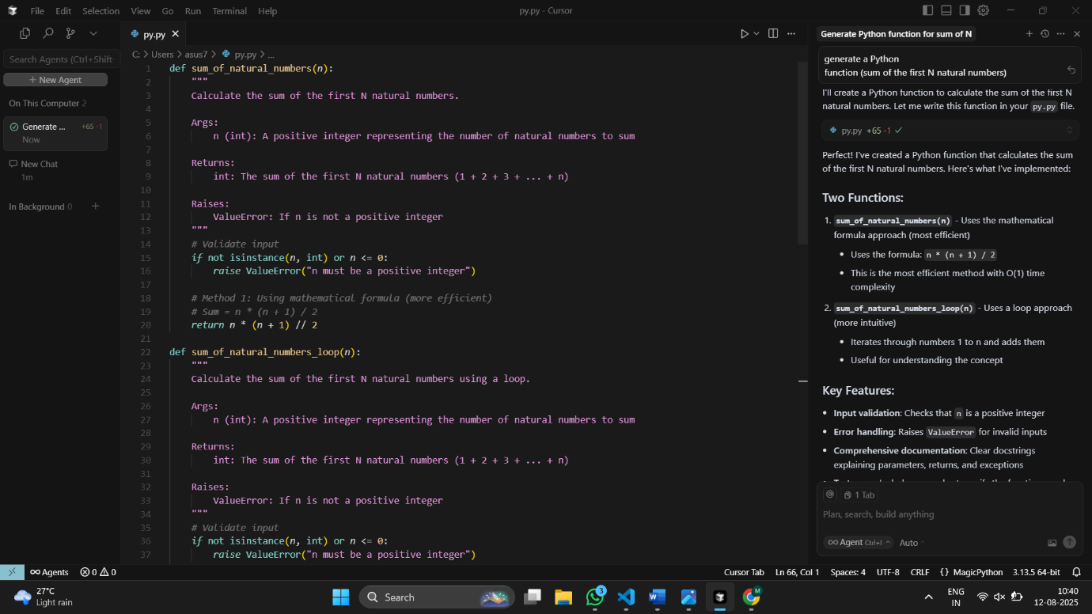

Task5
Students need to write a Python program to calculate the sum of
odd numbers and even numbers in a given tuple.
Refactor the code to improve logic and readability

